Trent Giever

Ch 13 Vulnerability Assessment and Data Security

Project 13-3

7/31/18

Project 13-3 Using a local port scanner

13-3-6

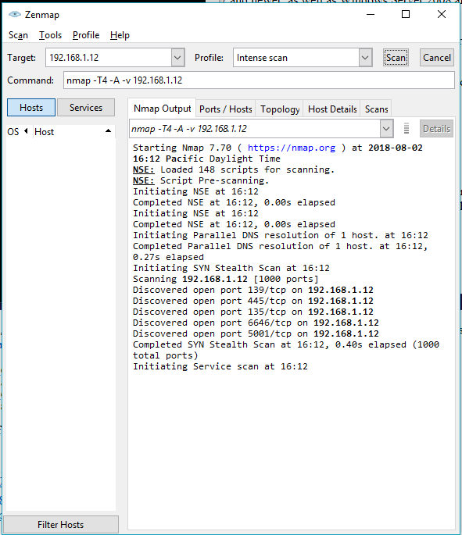

This can help an attacker not have to do it manually but use a program to test the ports of a network.

13-3-12

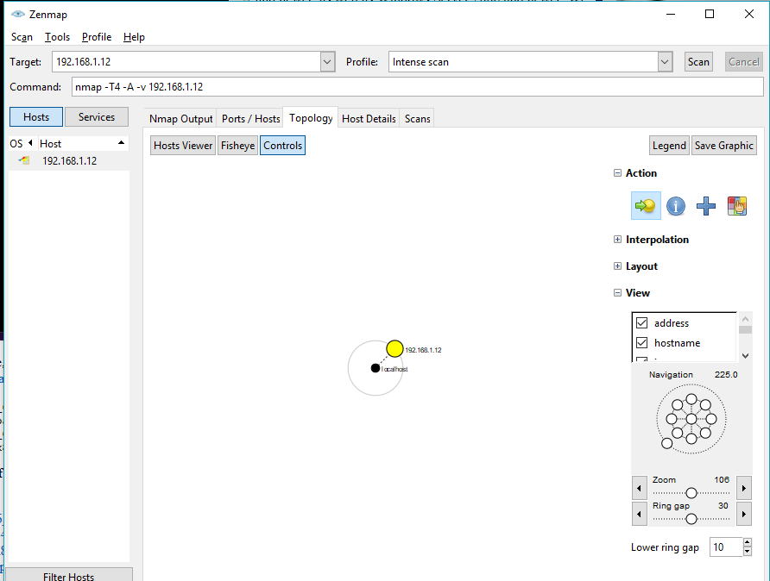

The info provided is limited since it is a local network system and can help an attacker if on the network by the varies tools.